# Lab 07 – JOINS

This Lab relates to the following Course Learning Requirements:

CLR 1: Follow lab policies and procedures for etiquette, software licensing requirements and lab submissions

CLR5: Use basic SQL SELECT Statements to perform inner joins, outer joins and subqueries

Objective:

The objective of this lab is to make sure that you know how to use different join statements and use subqueries.

# Pre-Lab Instructions:

1. Read Module 7 and Module 8

**Lab Tasks:**

1. Import the Lab07DB.sql in the workbench and refresh the schemas.
2. You will execute some commands to get information out of the database. Each bullet point represents an individual task.
   * Display all students and ORDER BY the program.
   * Display everything FROM student LEFT JOIN professor ON common program.
   * Display professor name and professor program FROM student RIGHT JOIN professor ON common program.
3. Your lab is to be submitted in 3 SQL files

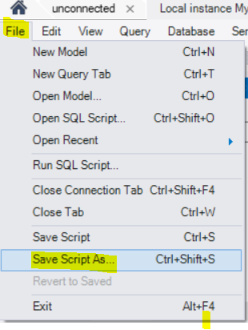

* + YourLastName_Left_Outer.sql
  + YourLastName _Right_Outer.sql
  + YourLastName _OrderBy.sql

**Lab Grading Rubric (3%)**

|  |  |
| --- | --- |
| YourLastName _Left_Outer.sql | /1 |
| YourLastName _Right_Outer.sql | /1 |
| YourLastName _OrderBy.sql | /1 |
| Total | /3 |
| Comments |  |